**TITLE, ARIAL 14, CAPS LETTERS, BOLD, CENTERED, SINGLE LINE SPACING**

Name Surname of Author(s), speaker underlined (if more than one author), Arial 12, centered, single line spacing

*Department of Affiliation, Arial 10, italic, centered, single interline*

*speaker’s email, arial 10, italic, centered*

KEYWORDS: first keyword, second keyword, third keyword, up to nine.

Write down your contribution in Times New Roman 12, single interline, left justified. There is no limit to the number of characters and/or words, you can write how many rows as you want within maximum two A4 pages (210x297 mm) with left and right margins of 2.00 cm and top and bottom margins of 1.25 cm.

No different first line. No indentation but for an ordered or unordered list.

Please be sure to include the bibliographic references in square brackets (don't write them as super or subscript) as this one[1][2]. Please do not insert page number or any other characters outside this space.

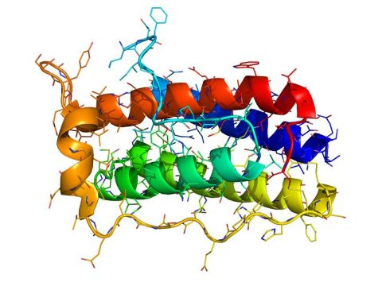Fig. 1: example of peptide

If you need to insert an image or a photo fell free to insert it inline, that is left or right justified, surrounded by text (padding 0.2 cm on every side) and with its caption under it (centered, italic, with progressive arab number), as the example picture, then cite it in your text simply as Fig. 1. If you need it, you can box your picture with a single black line 0.05pt.

The final Word document should be sent with image resolution at minimum 300 dpi, no password and printing allowed at high resolution.

At your convenience, overwrite the text in this template page with your to avoid a not well formatted contribution. Save you work in a file named “BIOSYMP2025_speaker-surname”.

At the very end of your text please leave just one blank row and then write down the references without indentation, as follows.

______________

**References:**

[1] Times New Roman 10, single interline

[2]. N. Surname, N. Surname, *Name of the Journal*, **year**, *volume*, start page – end page.

[3] If the referenced article need a different citation style, please use its own style